Name: K.Poorna chandu
Reg No: 192312585
Subject: ECA56 –5G / 6G Communication Systems

Experiment 3: -Spectrum Analysis of Sub-1 GHz, Mid-band & mm Wave by Plotting Propagation Loss.
AIM: To analyse the propagation loss characteristics of different frequency bands (Sub-1 GHz, Mid-band, and mm Wave) in wireless communication systems and compare their performance over varying distances using MATLAB.
Objective 1:
MATLAB Code:
clc; clear; close all;
d = 0.1:0.1:5; % Distance (km)
f = [900 3500 28000]; % Frequency (MHz)
PL1 = 32.44 + 20*log10(f(1)) + 20*log10(d);
PL2 = 32.44 + 20*log10(f(2)) + 20*log10(d);
PL3 = 32.44 + 20*log10(f(3)) + 20*log10(d);
figure
% -------- Graph 1 --------
subplot(2,1,1)
plot(d,PL1,'b','LineWidth',2); hold on
plot(d,PL2,'r','LineWidth',2)
plot(d,PL3,'k','LineWidth',2)
title('Propagation Loss vs Distance')
xlabel('Distance (km)')
ylabel('Loss (dB)')
grid on
% -------- Graph 2 (NO legend used to avoid error) --------
subplot(2,1,2)
Freq = [900 3500 28000];
Loss = [PL1(10) PL2(10) PL3(10)];
plot(Freq,Loss,'-o','LineWidth',2)
title('Propagation Loss vs Frequency')
xlabel('Frequency (MHz)')
ylabel('Loss (dB)')
grid on
Output:
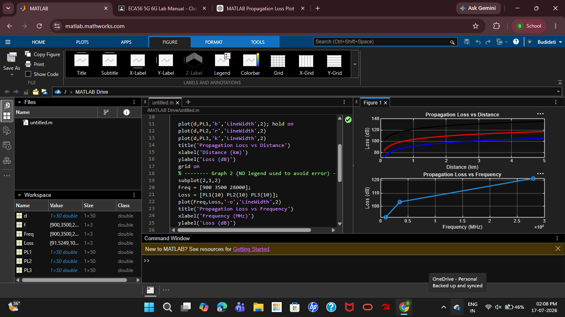
Objective 2:
MATLAB Code:
clc; clear; close all;
d = 2; % fixed distance (km)
f = [900 3500 28000]; % MHz
PL = 32.44 + 20*log10(f) + 20*log10(d);
figure
% -------- Graph 1: Frequency vs Loss --------
subplot(2,1,1)
plot(f,PL,'-o','LineWidth',2)
title('Propagation Loss vs Operating Frequency')
xlabel('Frequency (MHz)')
ylabel('Propagation Loss (dB)')
grid on
% -------- Graph 2: Band Comparison --------
subplot(2,1,2)
bar(PL)
title('Comparison of Propagation Loss Across Bands')
xlabel('Frequency Bands (Index: 1=Sub-1GHz, 2=Mid-band, 3=mmWave)')
ylabel('Propagation Loss (dB)')
xticklabels({'Sub-1GHz','Mid-band','mmWave'})
grid on
Output:
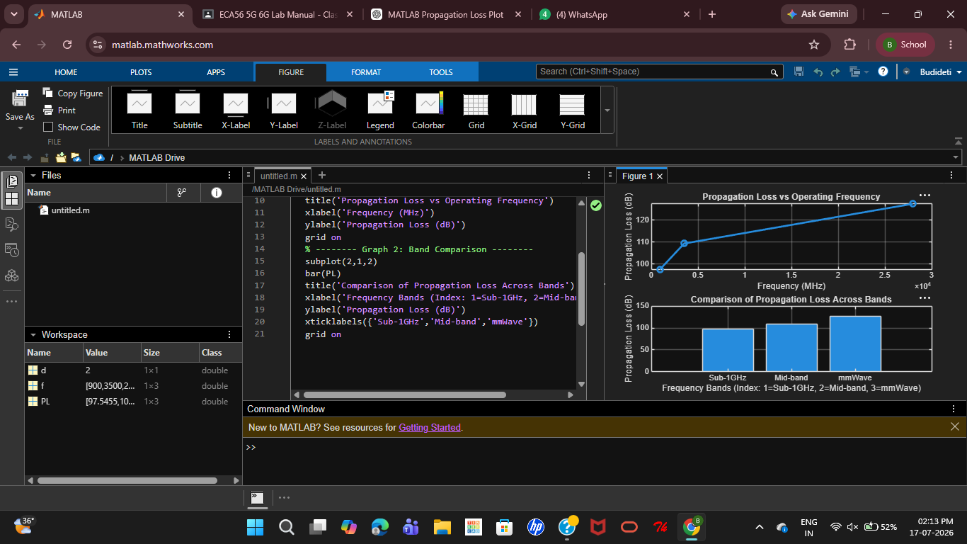
Result: The propagation loss for Sub-1 GHz, Mid-band, and mm Wave frequency bands was successfully analysed using MATLAB. The results showed that propagation loss increases with both frequency and communication distance, with mm Wave experiencing the highest attenuation and Sub-1 GHz providing the best coverage.

